**EDA on Stock Market using Time Series**

Interpretations

1. Imported the Packages required for time series.
2. Taken stocks of 4 tech companies (Apple, Microsoft, Google and Amazon) for EDA (Exploratory Data Analysis) using Time Series. Stock data has been taken from Yahoo finance.
3. Made a Data Frame using data from yahoo finance and arranged them in the following order, ‘Date’ ‘High’ ‘Low’ ‘Open’ ‘Close’ ‘Volume’ ‘Adj. Close’ ‘Company_name’. **\* Volume is the number of shares that changed hands (Traded) during a given day. * Adj closing price (used to examine historical returns) factors in anything that might affect the stock price after the market is closed.**
4. Described the Apple’s stock data.
5. Information regarding the Apple’s stock data.

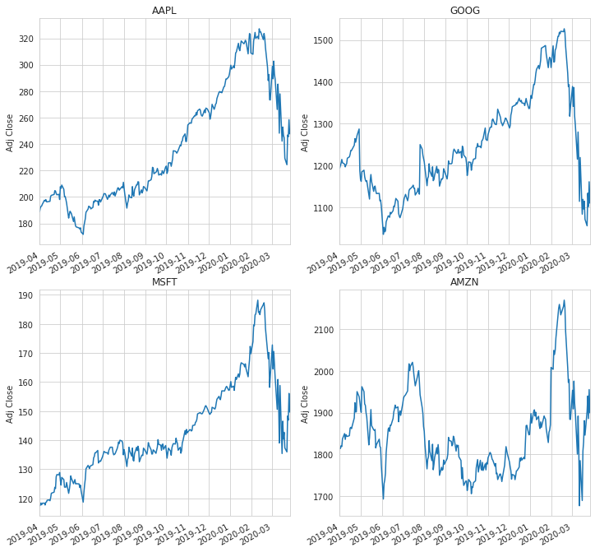

Above charts shows the adj. closing price of all 4 companies from 1st April 2019 to 30th March 2020. It can be observed that, all 4 companies fell drastically from start of march 2020. It can be seen that, Google and Amazon prices fell the lowest in mid- March as compared to Apple and Microsoft.

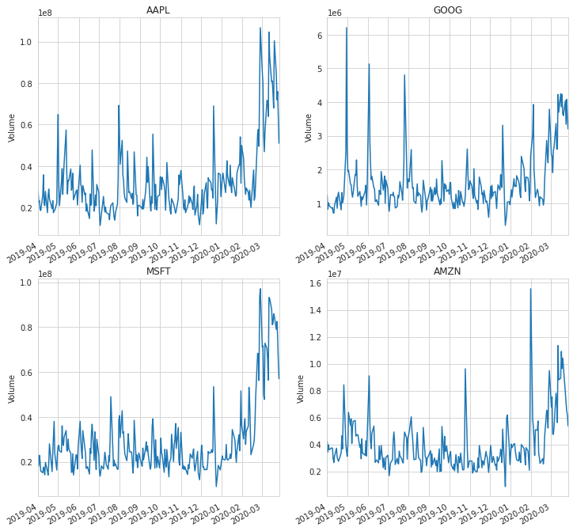

Above chart shows the volume of shares of the tech companies from 1st April 2019 to 30th March 2020.

1. Calculating Moving Average with lag of 10, 20, 50 days.

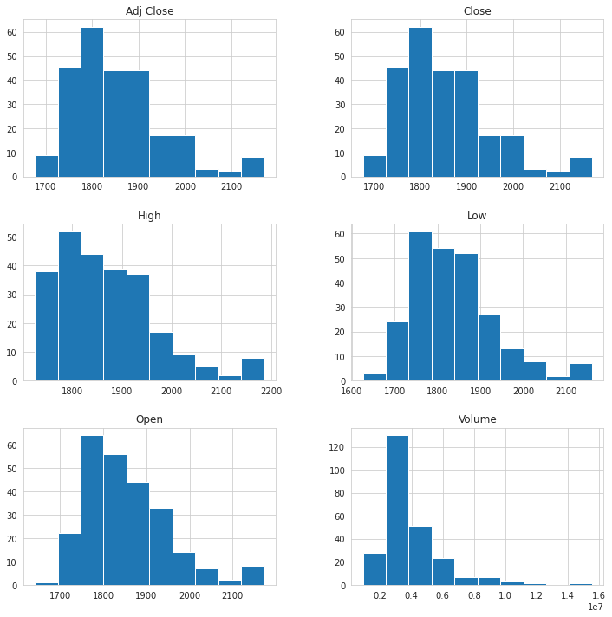

Above is the Histogram of Apple

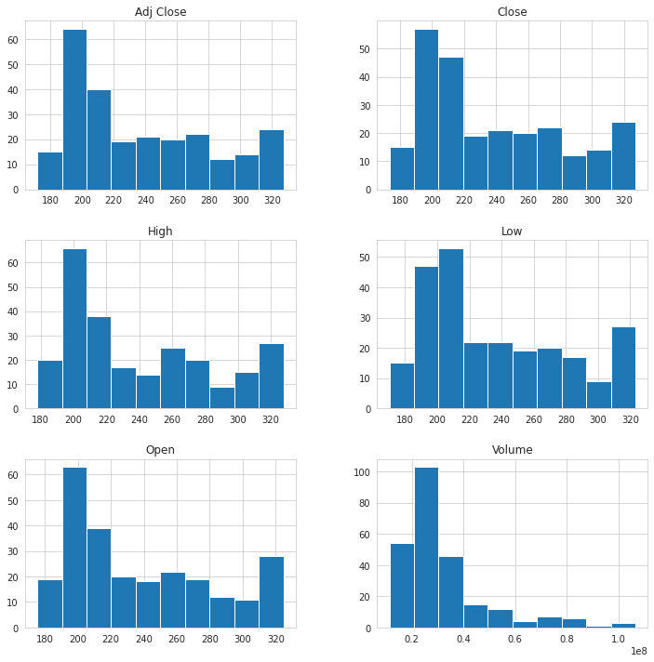

Above is the histogram of Google.

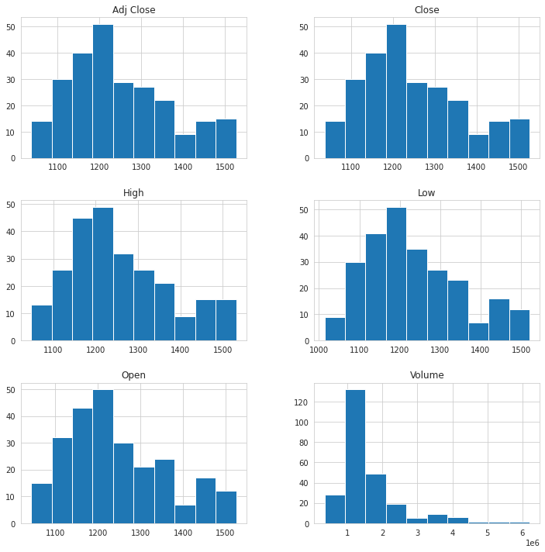

Above is the Histogram of Microsoft.

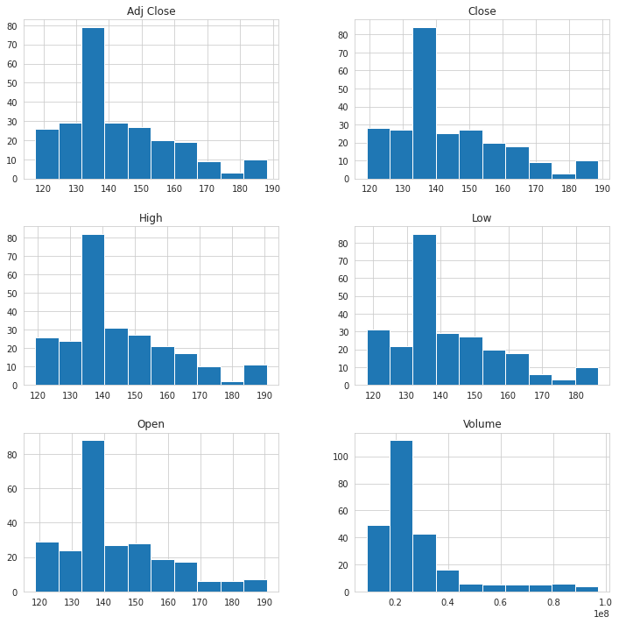

Above is the Histogram of Amazon.

1. Below is the subplot of tech companies with moving average of 10 days, 20 days and 50 days.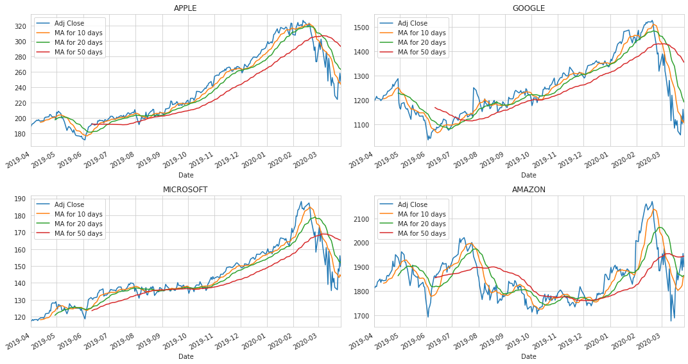
2. Below we have plotted the percent change of daily returns using pct_change() on Adj. close column.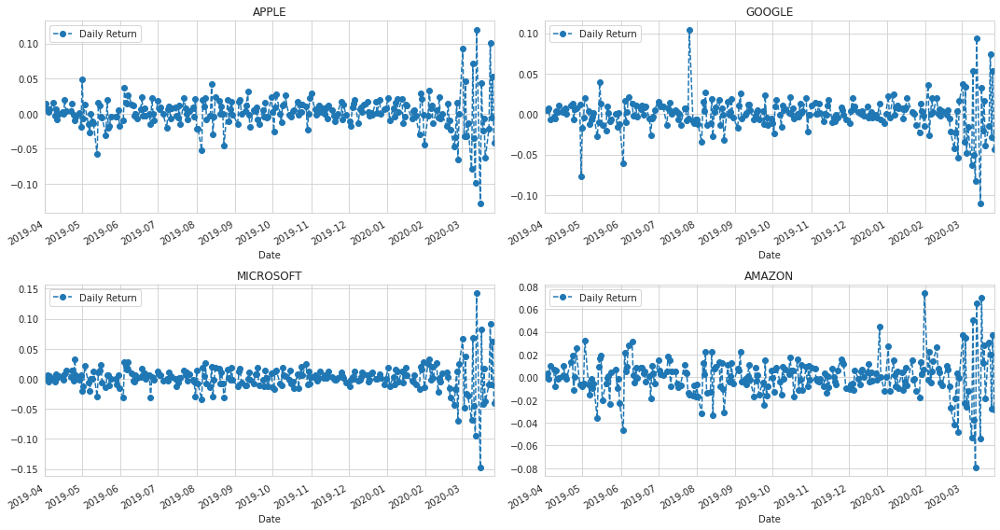
3. Below we have plotted the same percent change of daily returns but using distplot() from seaborn package to get a better view. It gives a quick view at a univariate distribution of a stock.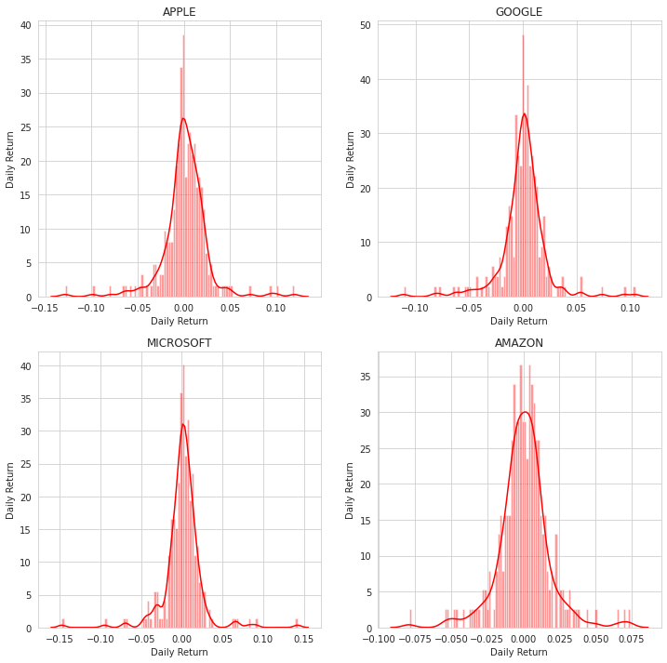
4. Created a new dataframe which has only the closing prices of all tech companies.
5. Added a new column of returns in the above dataframe.
6. Comparing google to itself using jointplot() from seaborn package, this shows the perfect linear relationship.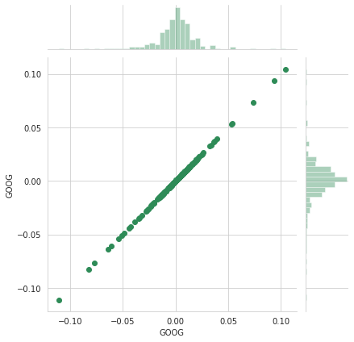
7. Below we’ve used jointplot() to see the relationship between Google and Microsoft on the basis of daily returns. We can observe that both the stocks are linearly correlated to each other.

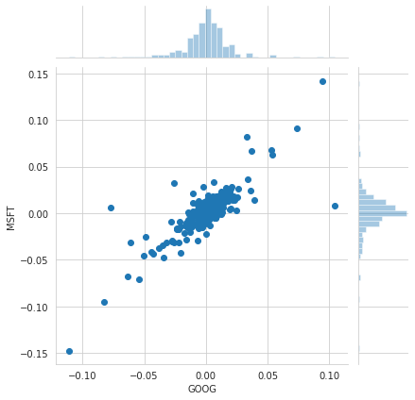

1. Below we’ve used pairplot() for comparison between all 4 companies. It shows how each tock is related to each other. We can say that every tech company related to each other. If stock price of one company increases then it will affect other companies stocks.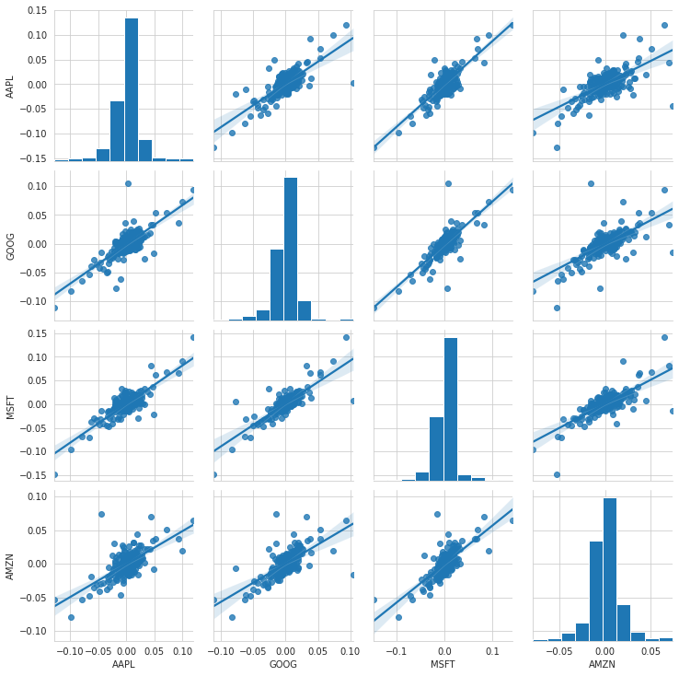
2. For below diagram, we’ve used PairGrid() function from seaborn package. In this we’ve used scatter plot from matplotlib package for upper triangle of the matrix and for lower triangle we’ve used kdeplot from seaborn package. This chart is same as pairplot() chart but the only difference is that we’ve used different charts to represent the relationship between the stocks.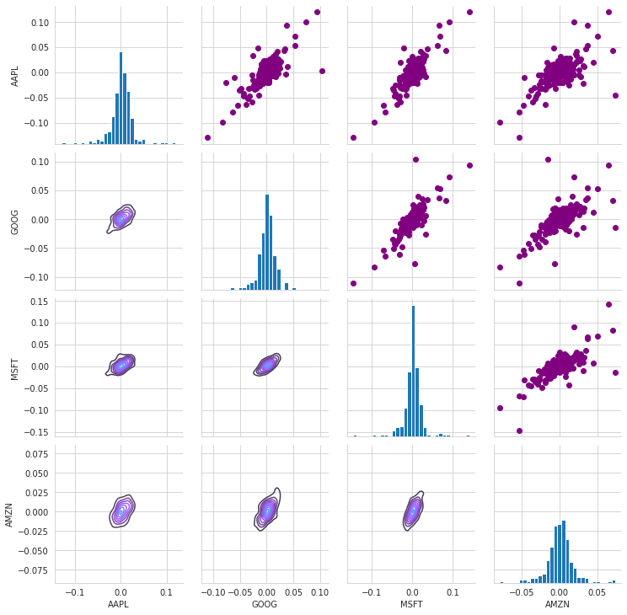
3. In the below chart, we’ve again used the PairGrid() for visualization but this time we’ve taken closing price instead of daily returns.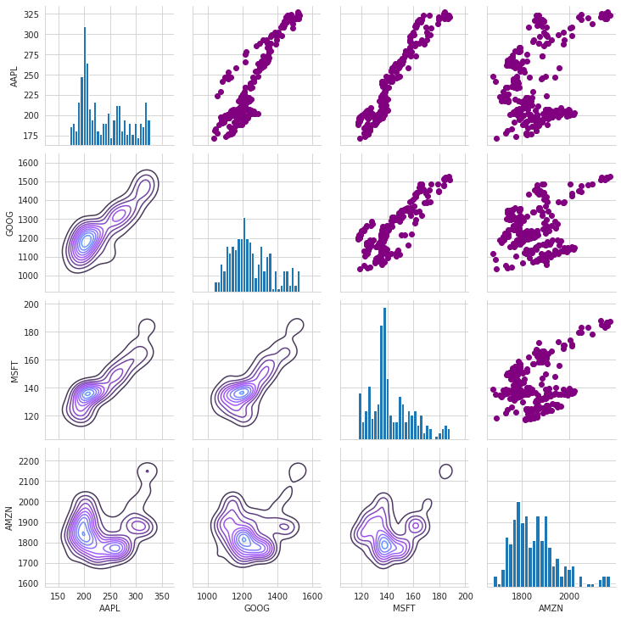
4. Below we’ve used a heatmap() from seaborn package to see the correlation between daily returns of the stocks from numerical point of view.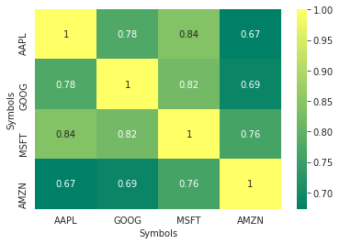
5. Below we’ve used a heatmap() from seaborn package to see the correlation between closing price of the stocks from numerical point of view.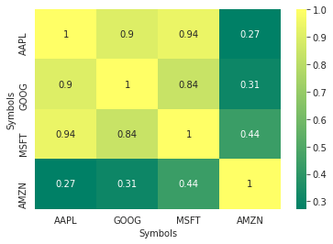
6. In conclusion, on the basis of returns we’ve made a graph of Expected returns V/S Risk. On the x-axis is Expected Returns and on the y-axis is Risk. We calculated the mean and standard deviation of the returns. So, from the chart it can be interpreted that

* Google will give less returns but its more riskier
* Amazon will give more returns and is less riskier
* Microsoft will give more returns but its risk is greater
* Apple will give the maximum returns compared to others but it’s also the most riskier stock.

